**JJTU FACILITIES**

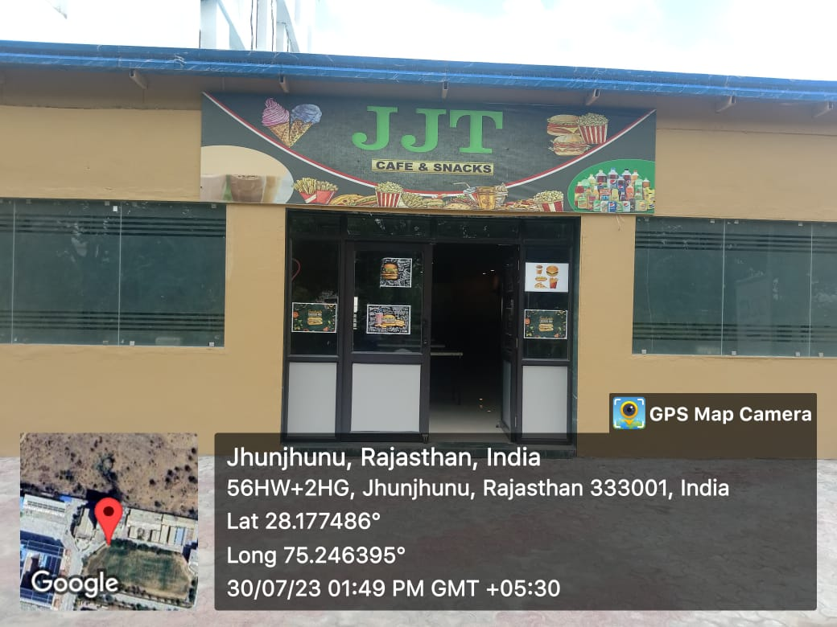

**CAFETERIA**

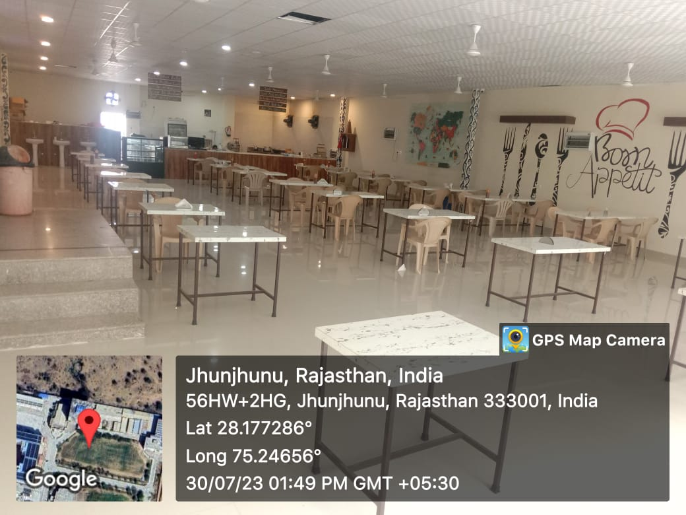

**CAFETERIA**

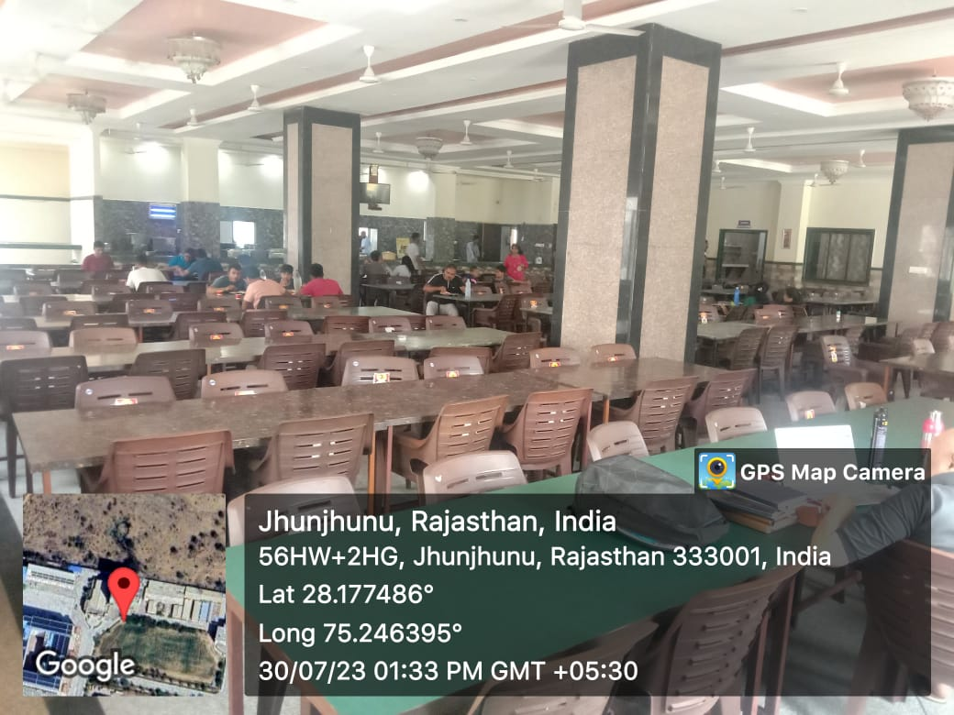

**CANTEEN**

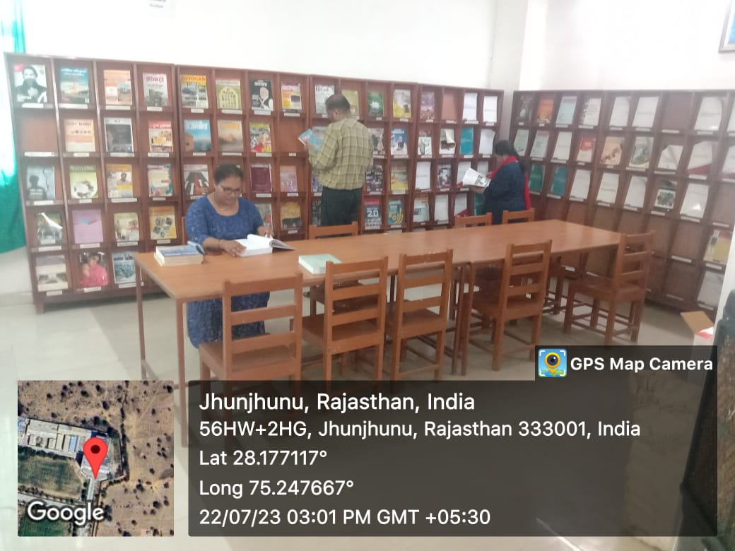

**CENTRAL LIBRARY**

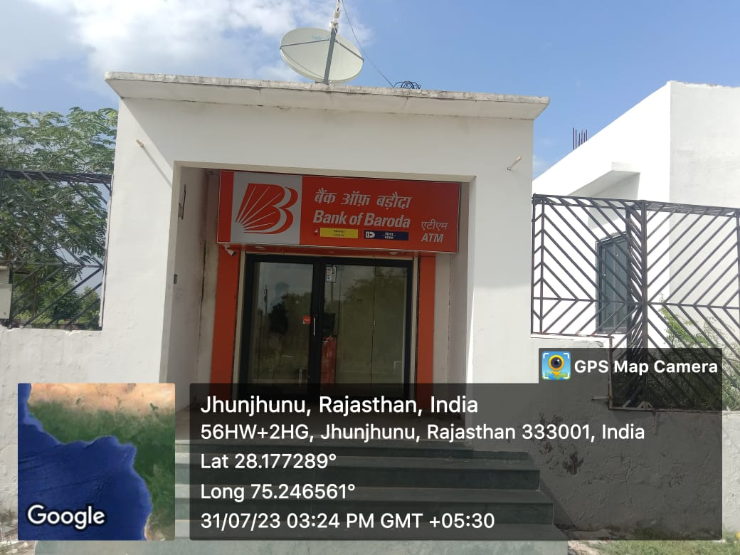

**BOB ATM SERVICE**

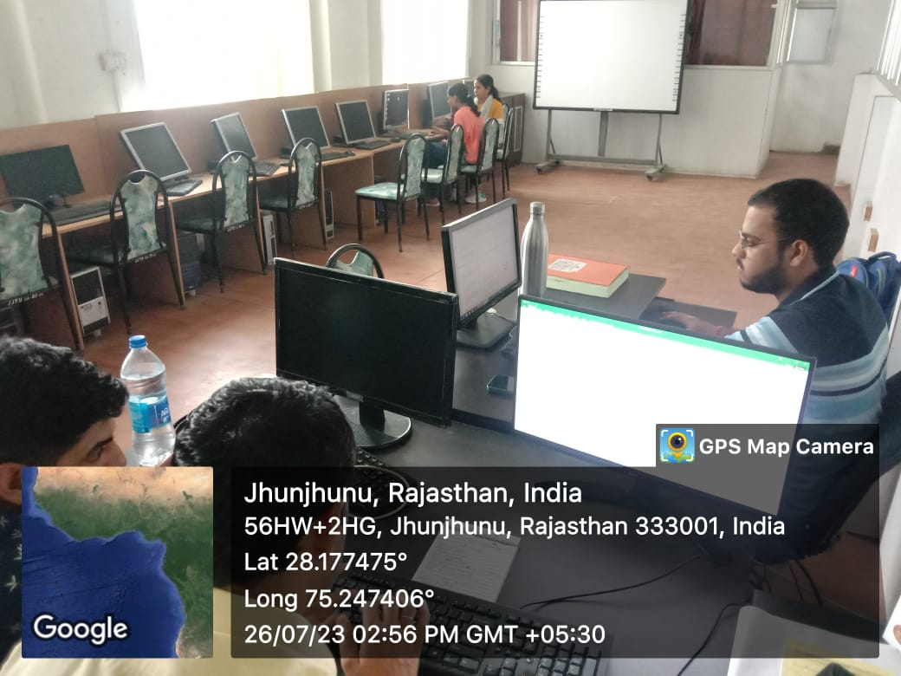

**E LIBRARY**

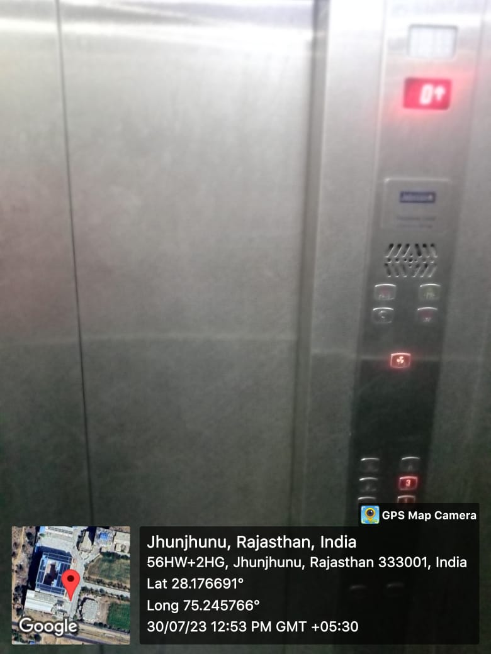

**LIFT SERVICE ACADEMIC BLOCK I**

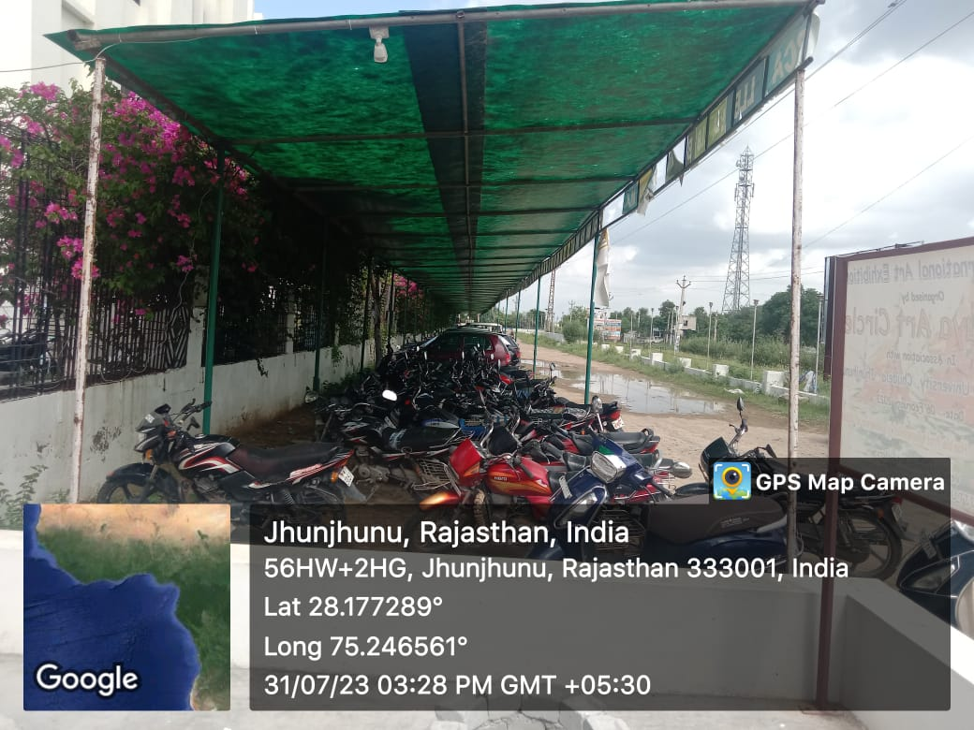

**TWO WAHEELER PARKING**

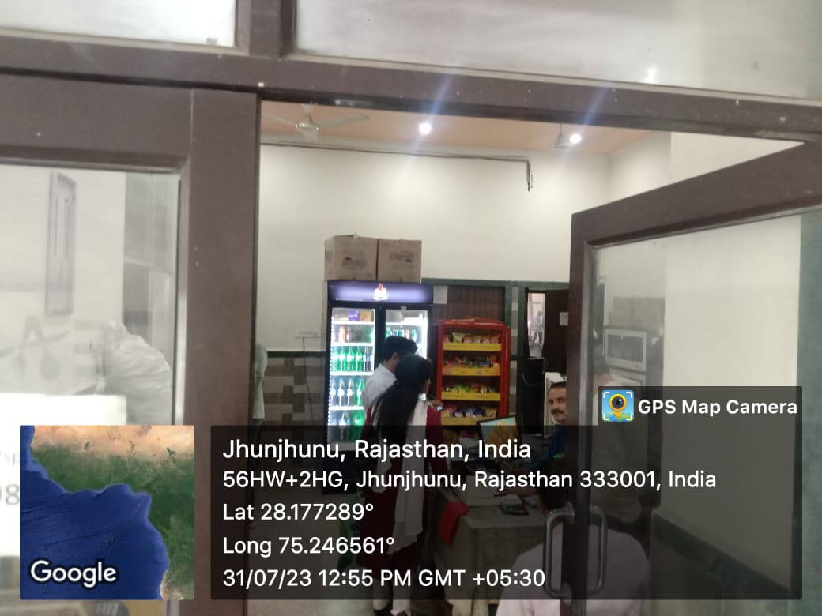

**PROVISION STORE**

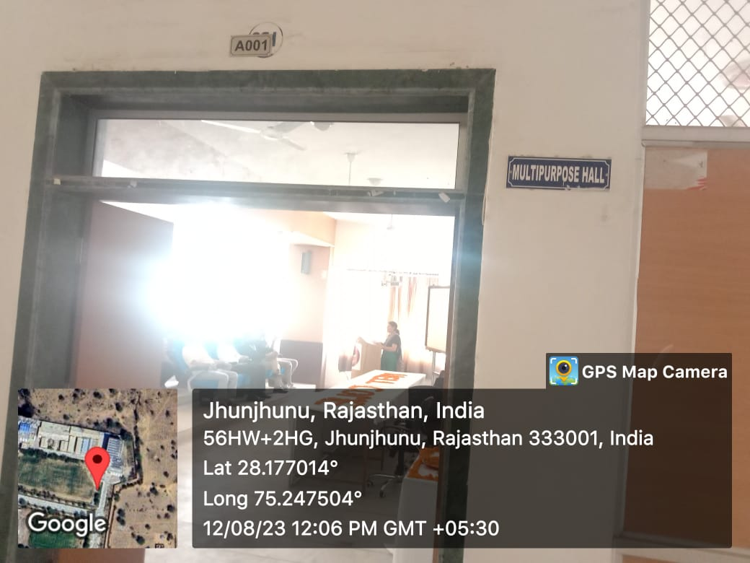

**SEMINAR HALL ACEDAMIC BLOCK 2 GROUND FLOOR**

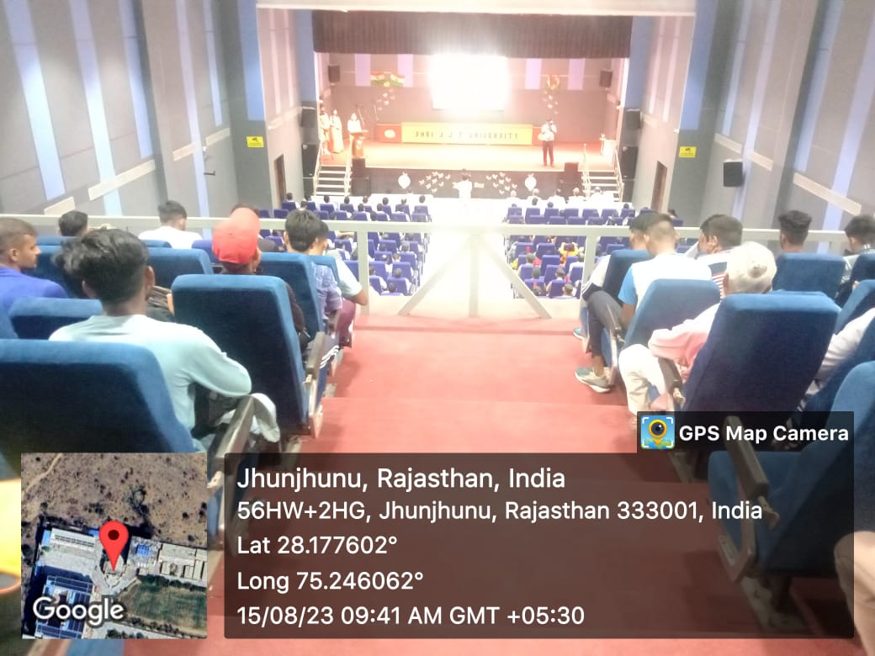

**Auditorium Inside View**

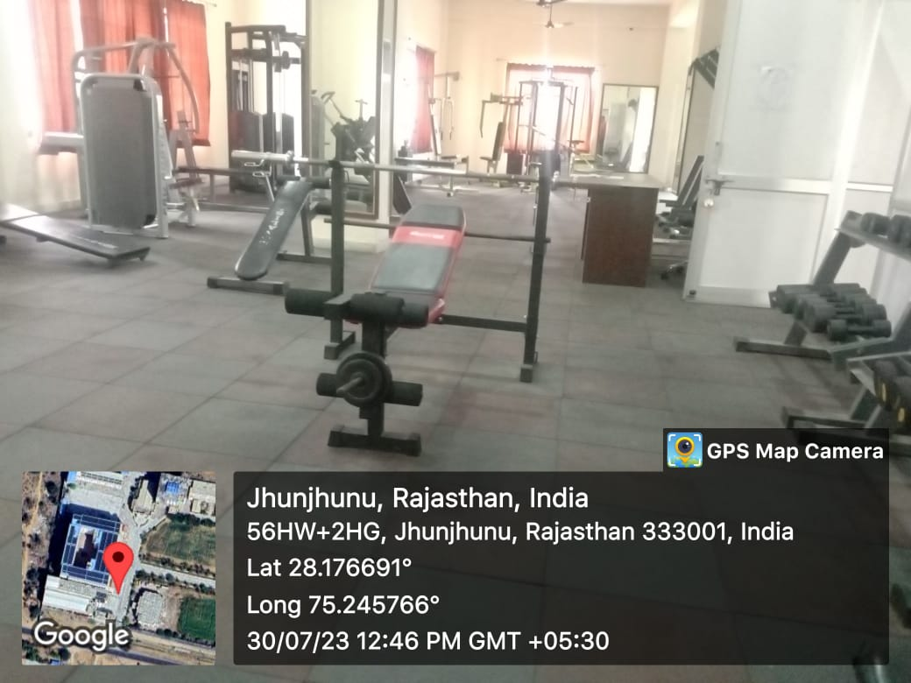

**JJTU FITNESS CENTER**

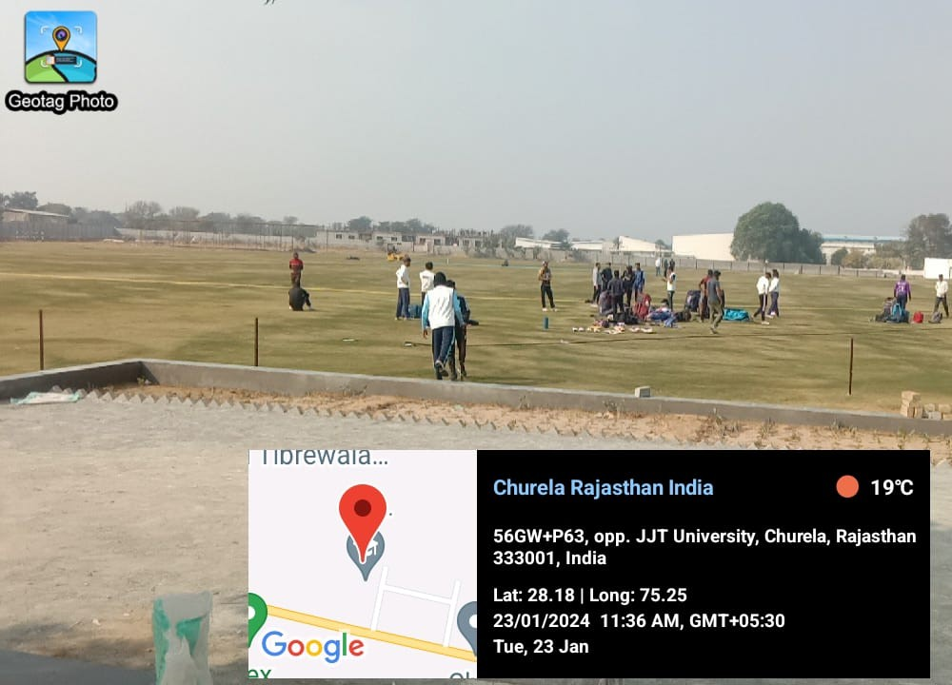

**Sports Ground**

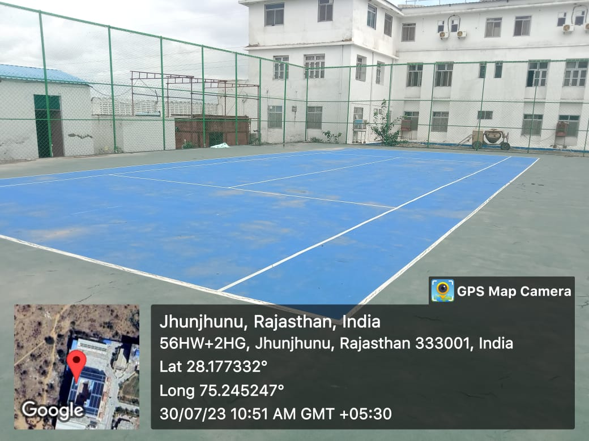

**TENNIS COURT**

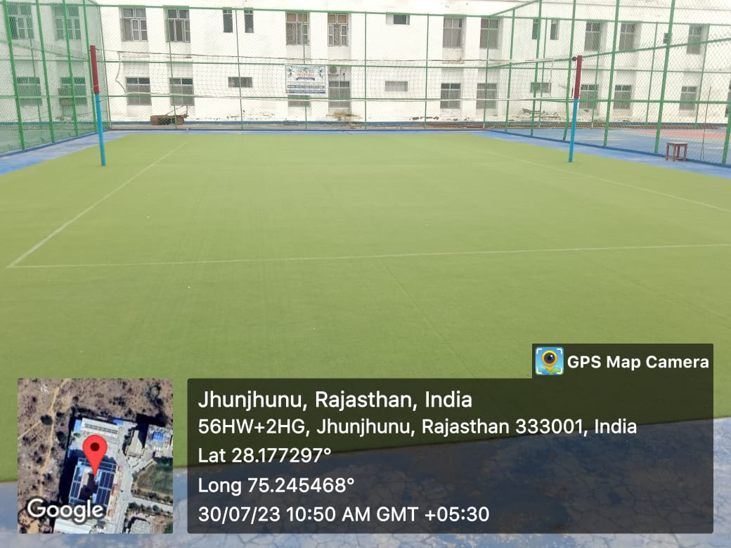

**VOLLYBALL COURT**

INDOOR GAMES

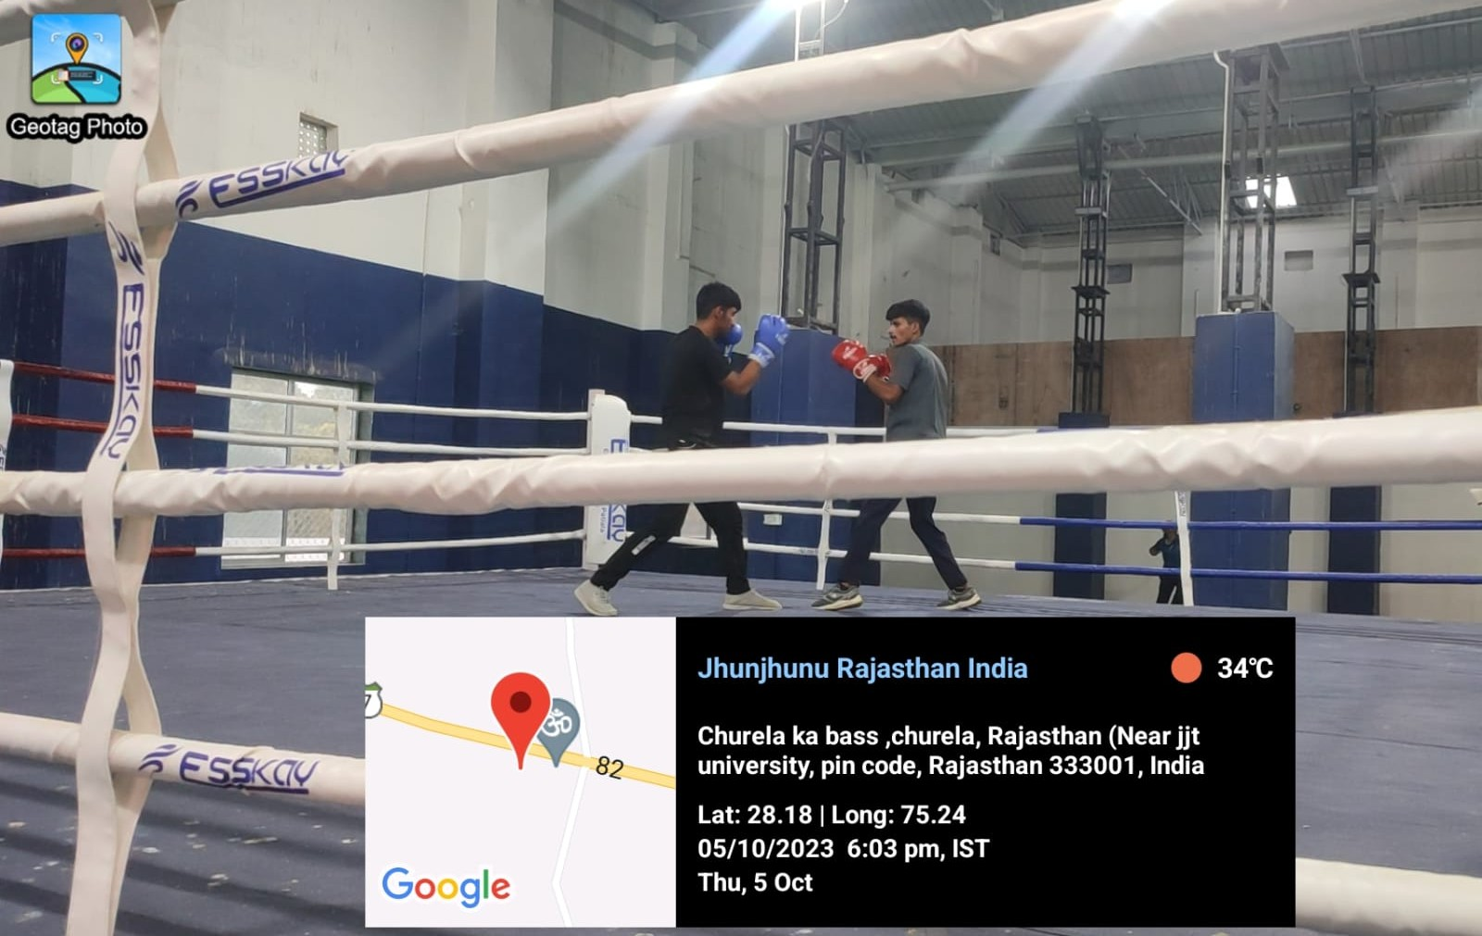

**BOXING RING**

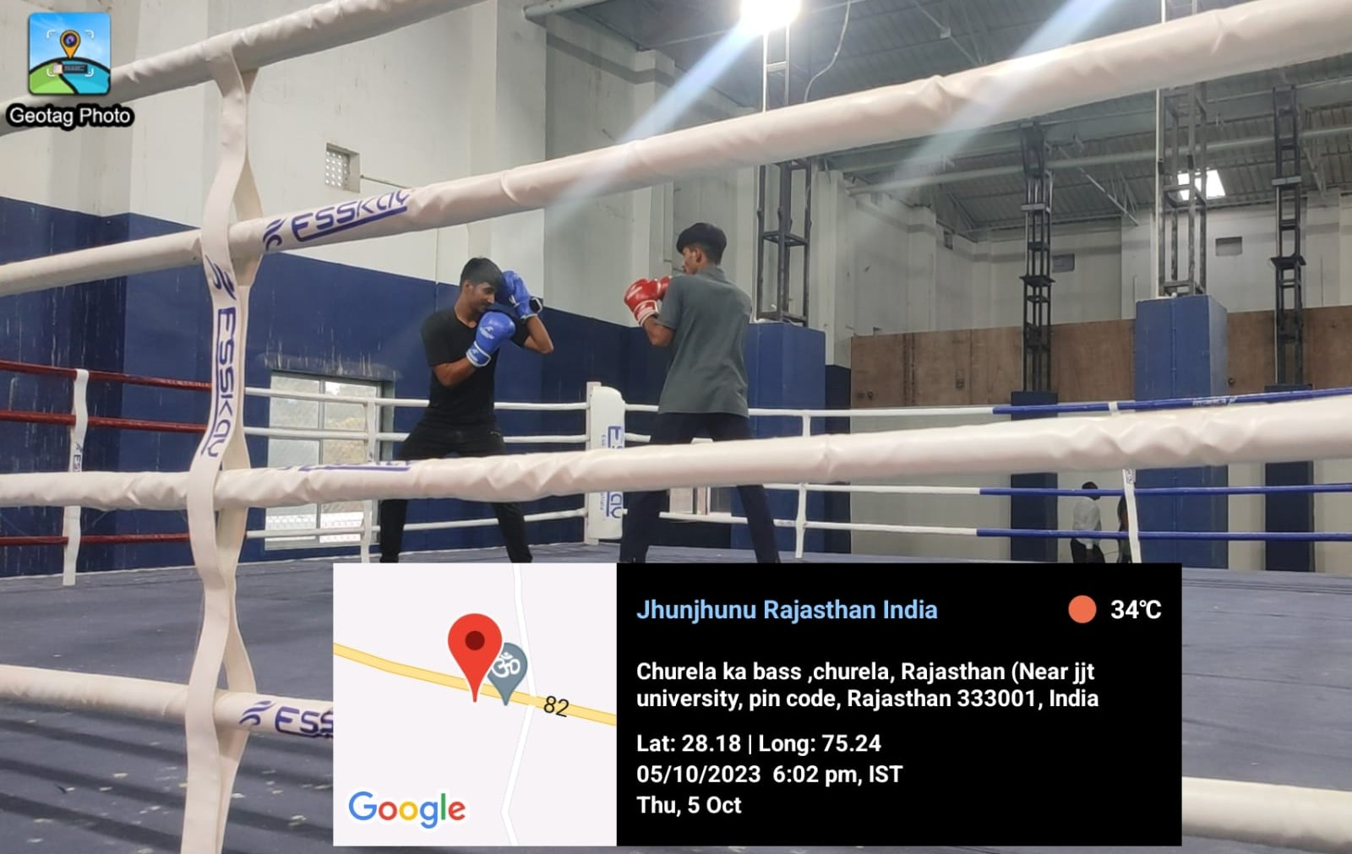

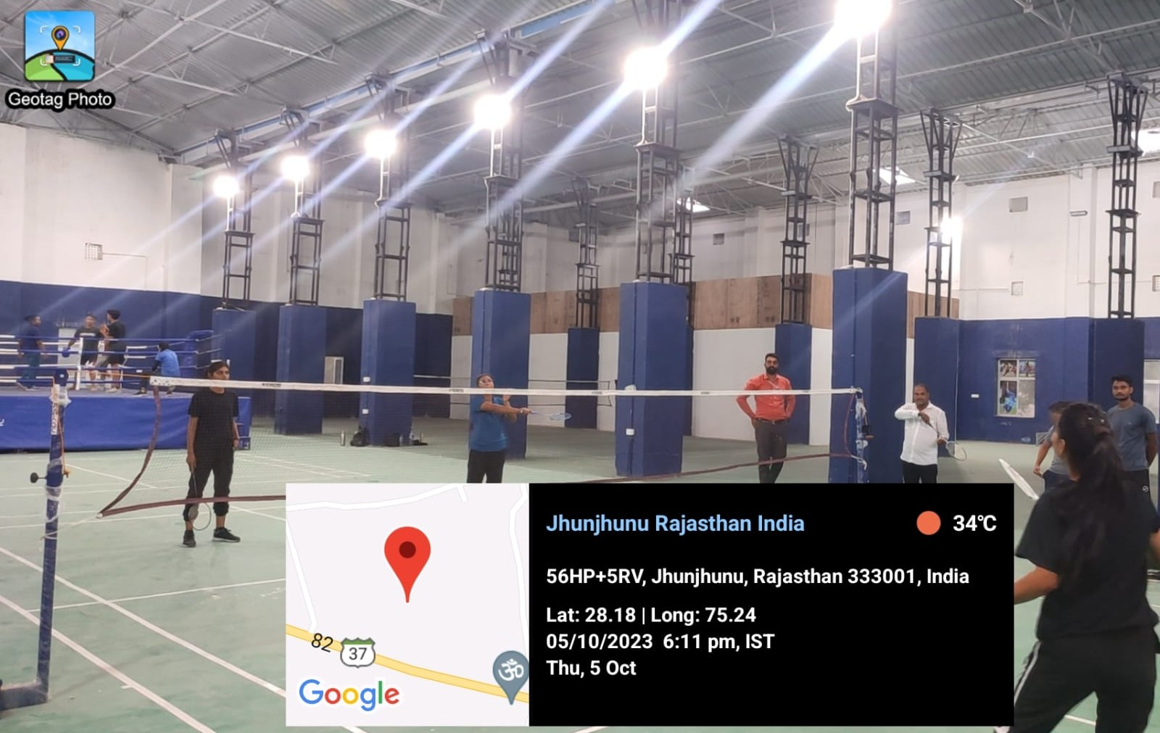

**BADMINTON COURT**

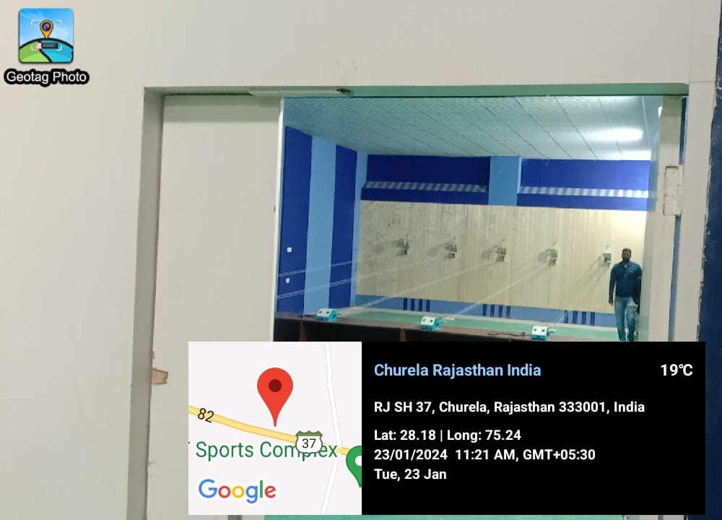

**Shooting Range**

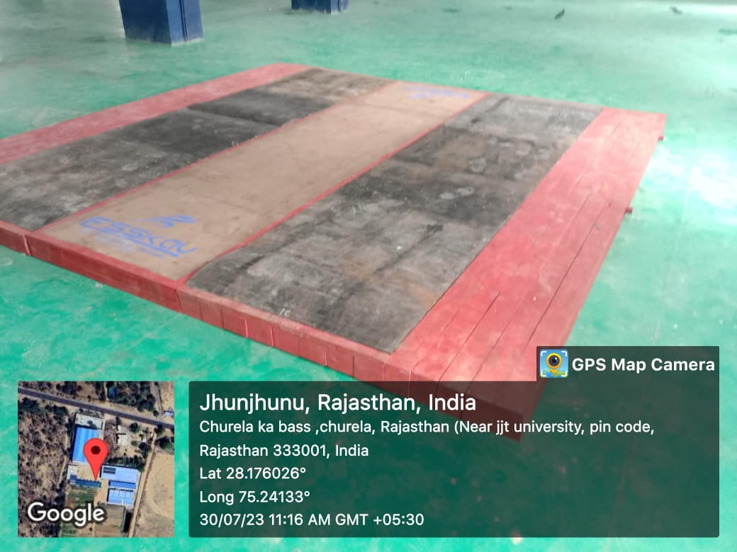

**WEIGHT LIFTING PLATFORM**

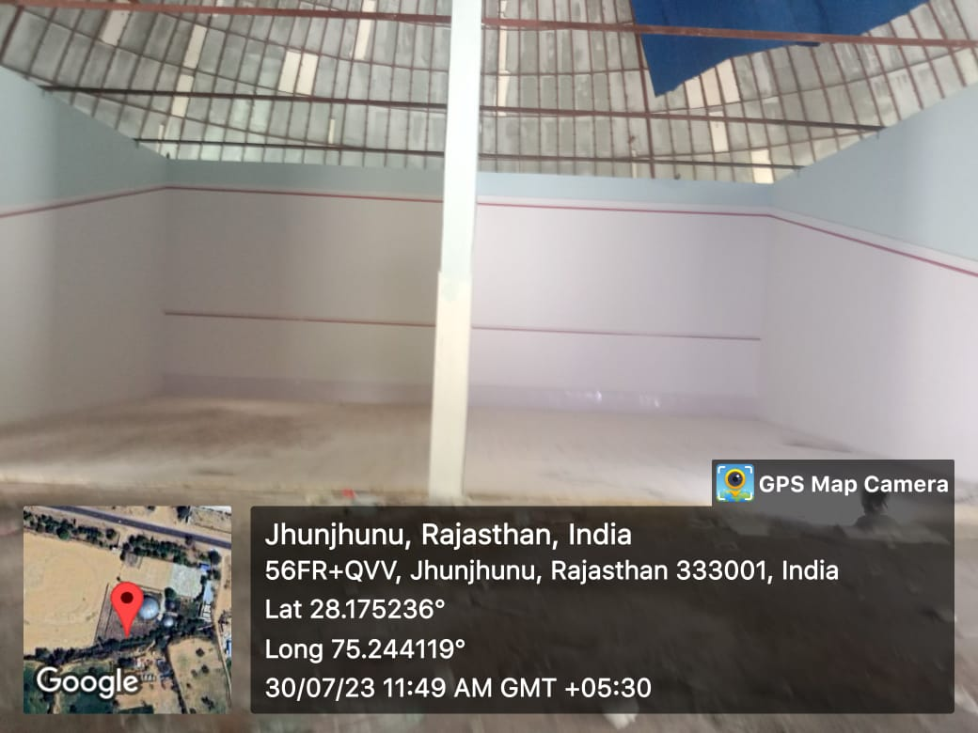

**SQUASH COURT**

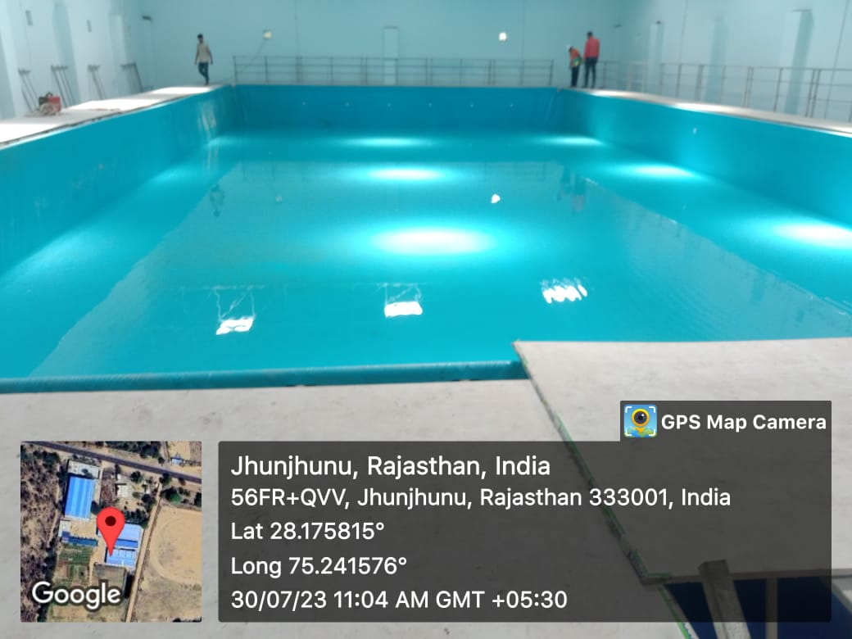

**SWIMMING POOL**

SOLAR SYSTEM ACEDAMIC BLOCK 1

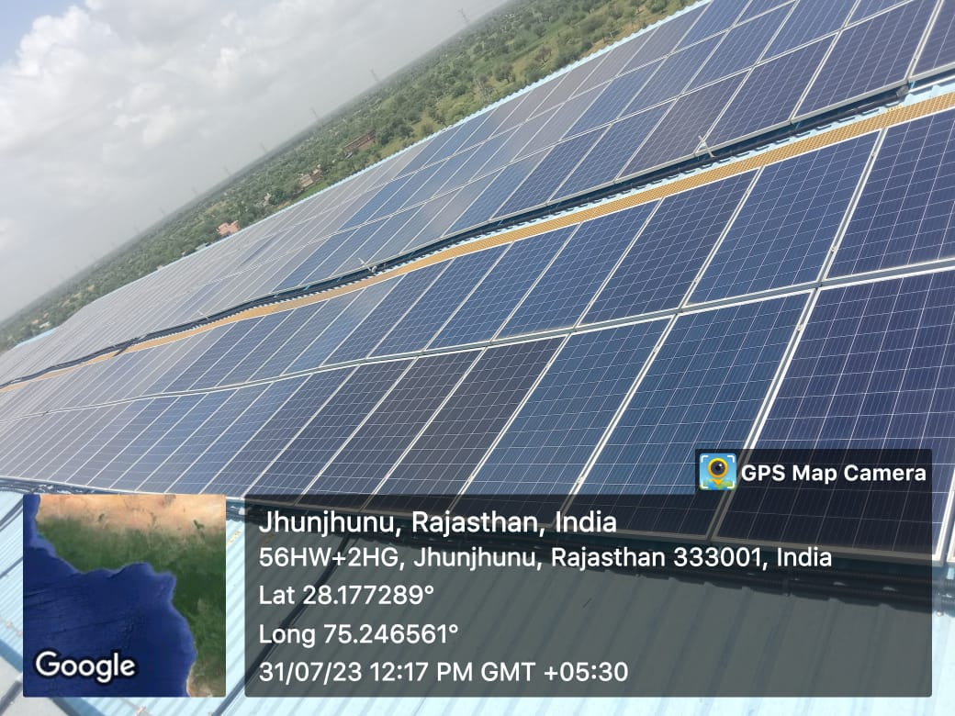

**SOLAR SYSTEM ACEDAMIC BLOCK 1**

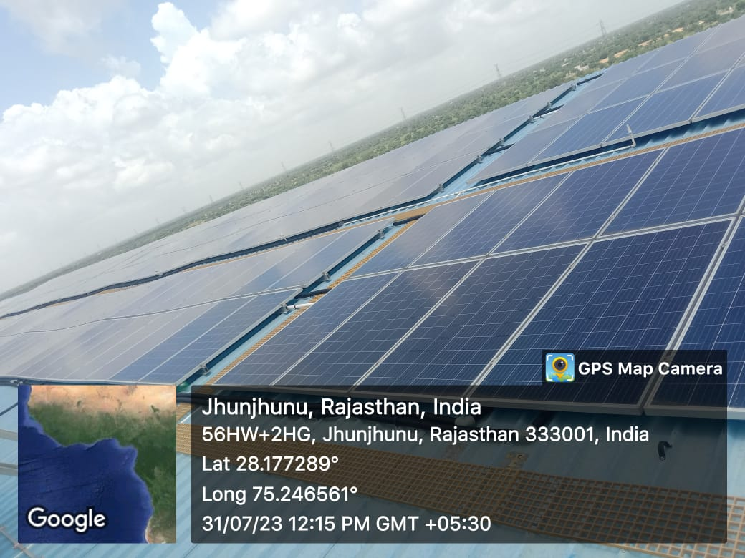

**SOLAR SYSTEM ACEDAMIC BLOCK 1**

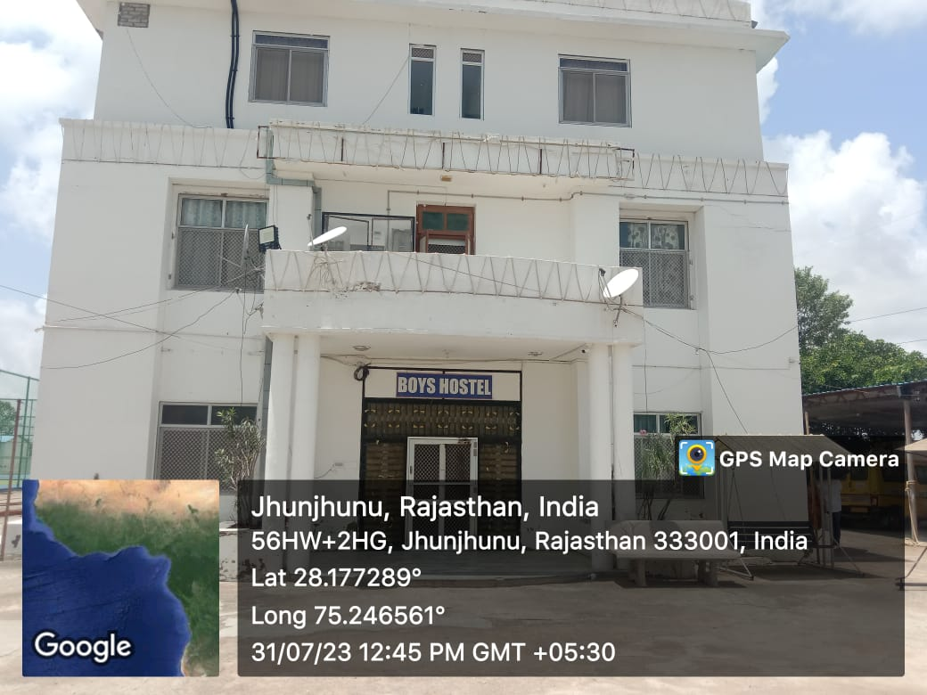

**Boys Hostel**

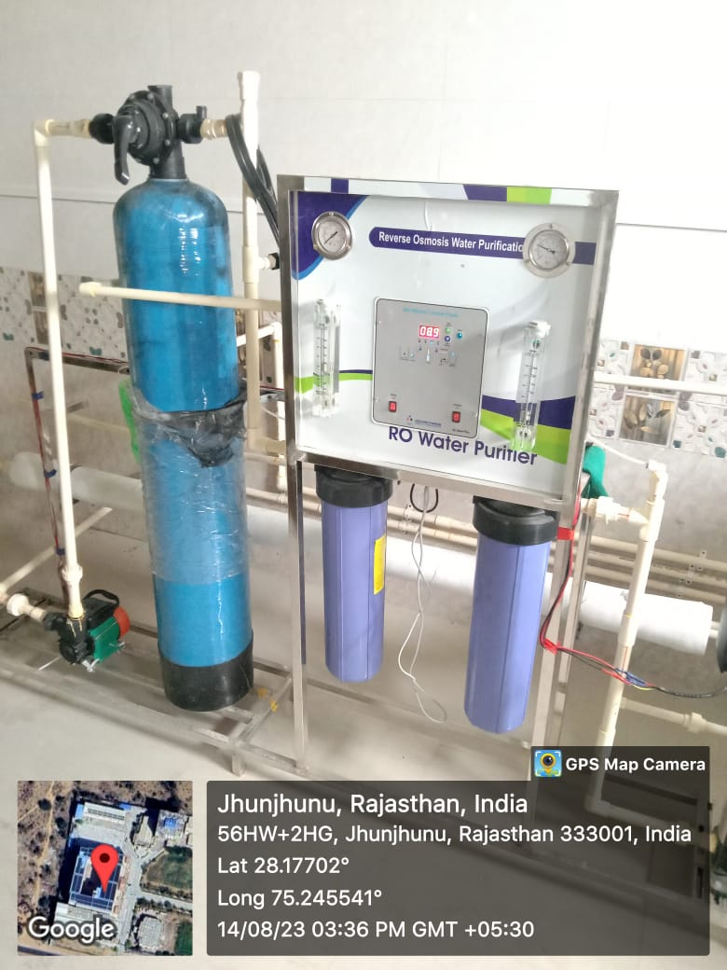

**RO Filter water Plant (Academic Block 1) 6th Floor**

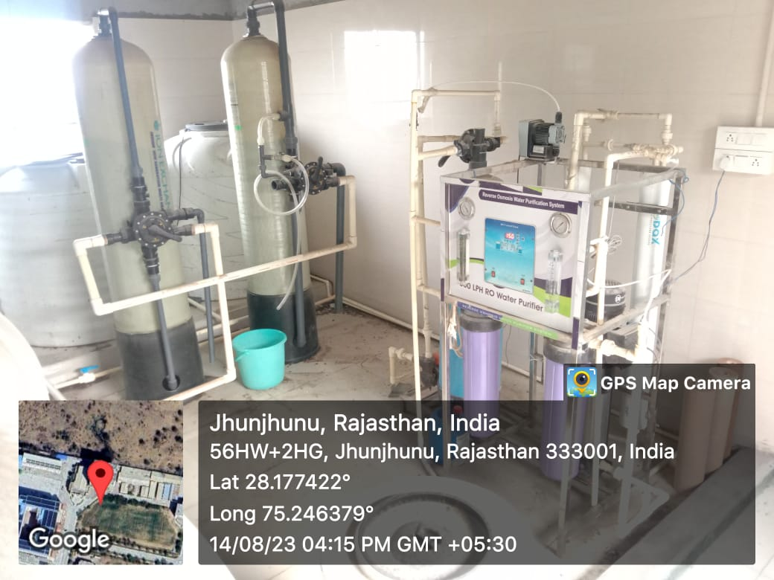

**RO Filter water Plant (Canteen 5TH Floor) CANTEEN Building**

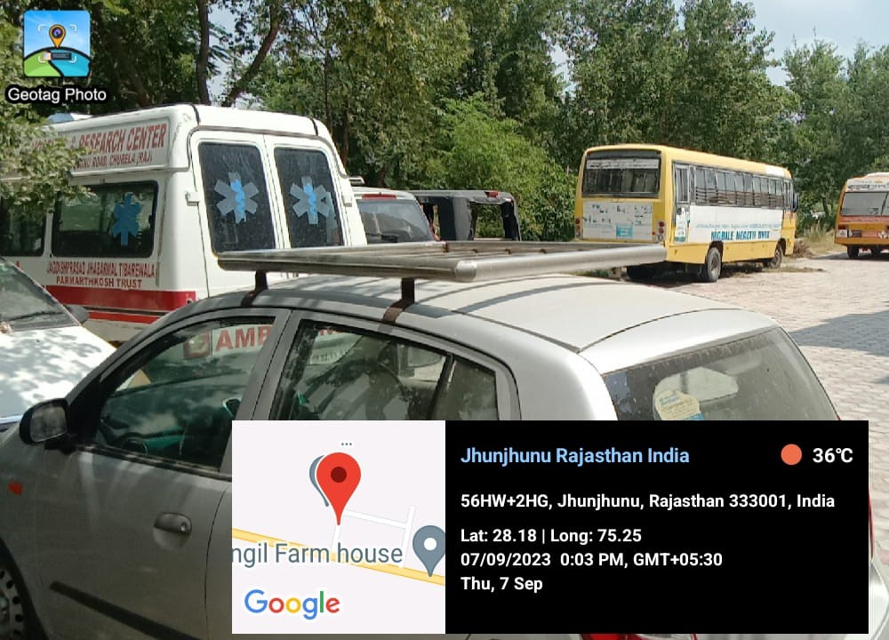

**Transportation Facilities**

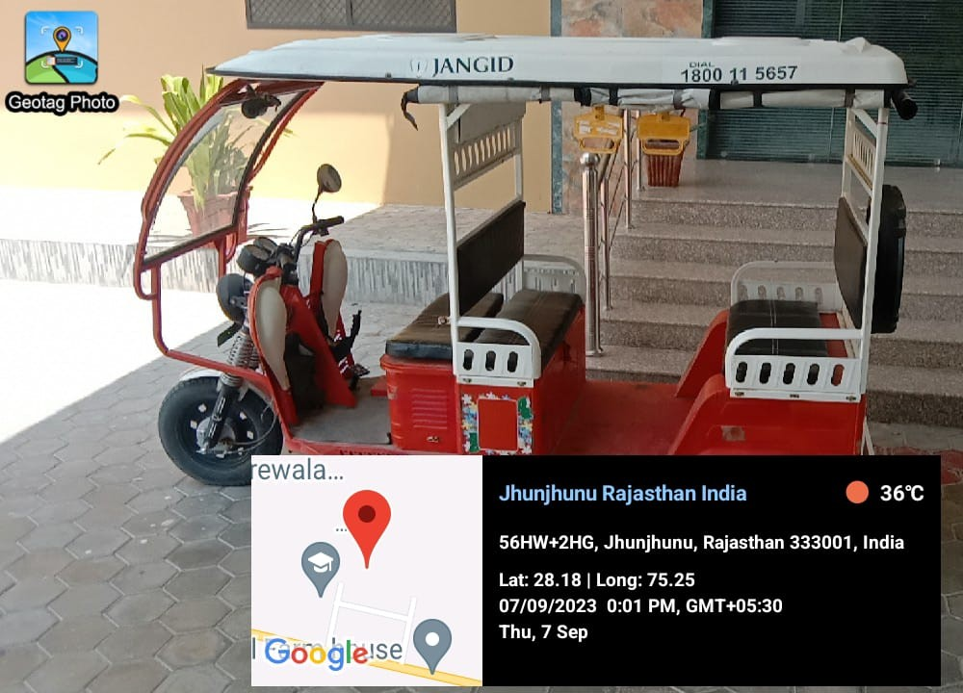

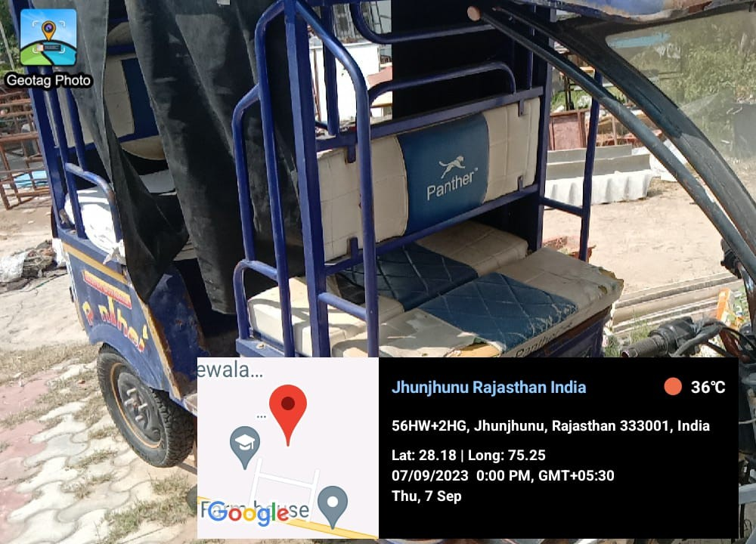

**E-Rickshaw**

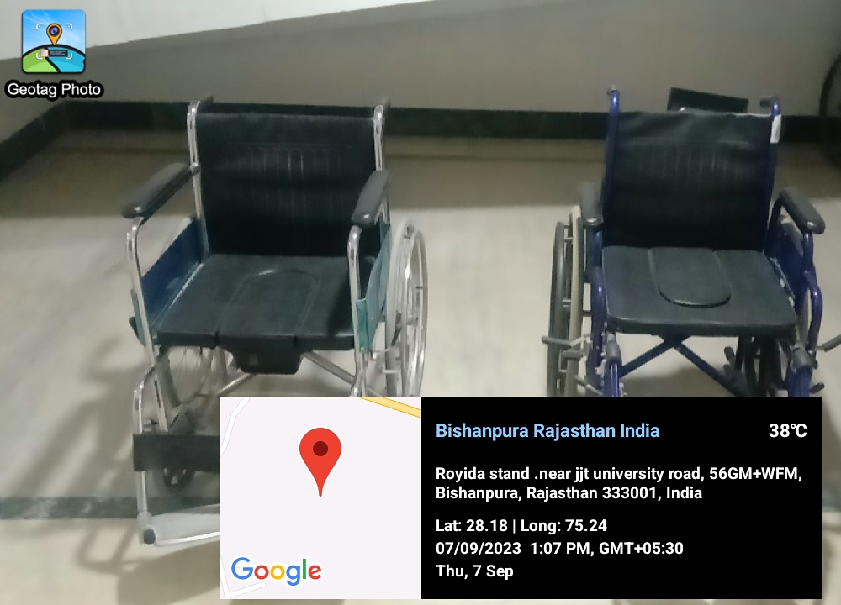

**Wheel Chair Facility**

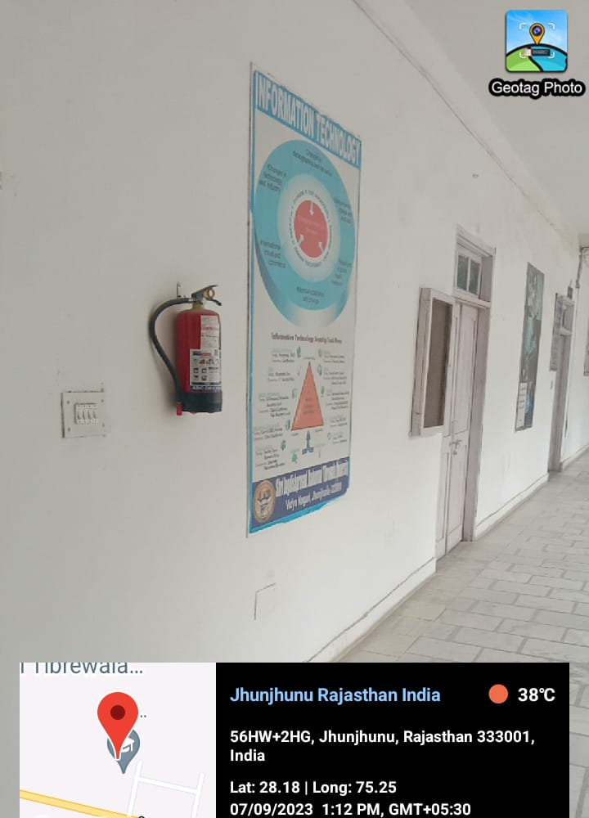

**Fire extinguisher**

**Yoga Hall**

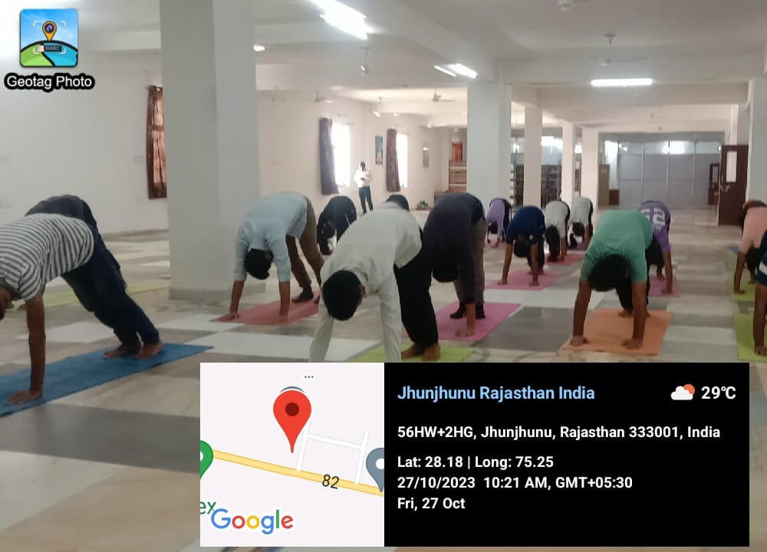

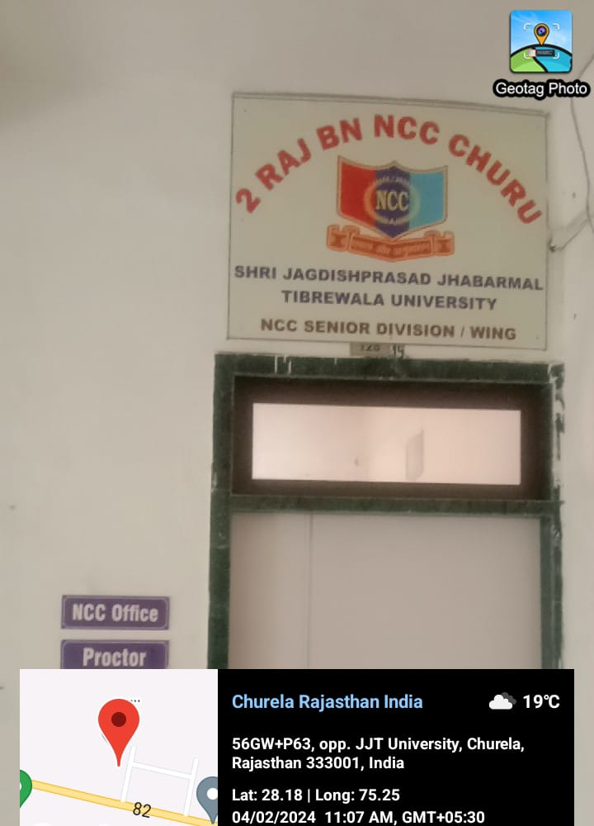

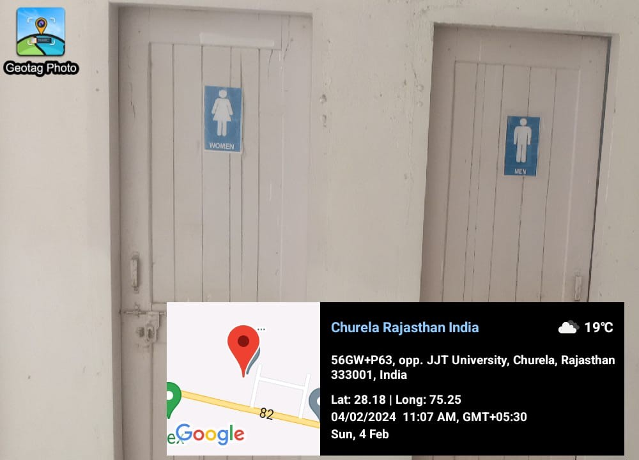

**Staff Washroom Facilities**

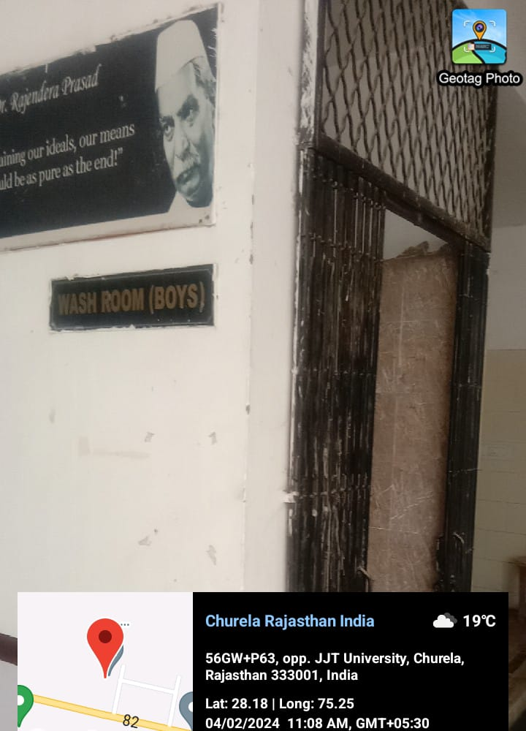

**Boys Washroom Facilities**

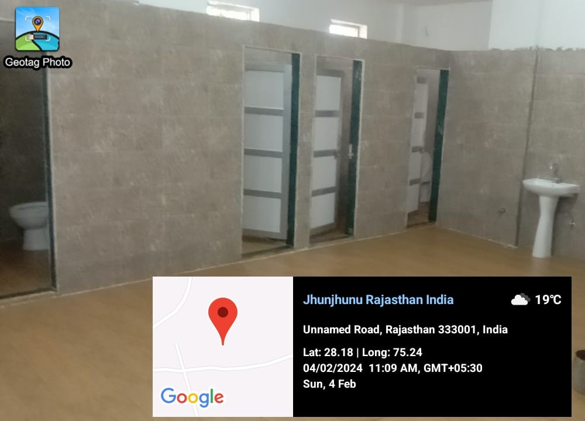

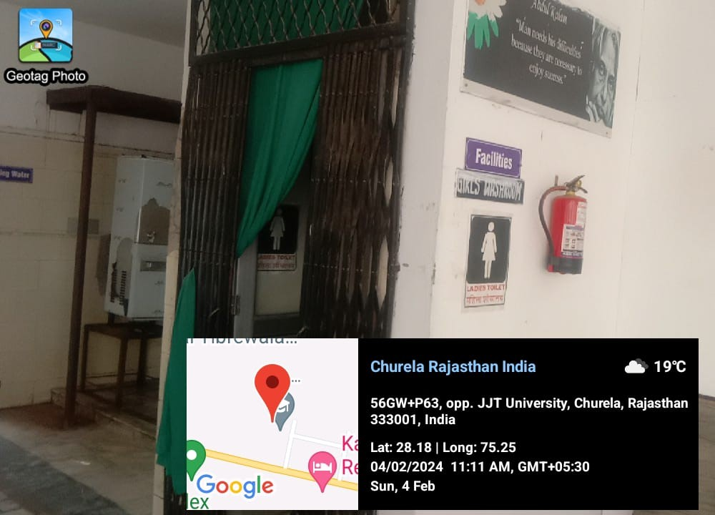

**Girls Washroom Facilities**

